Level 1

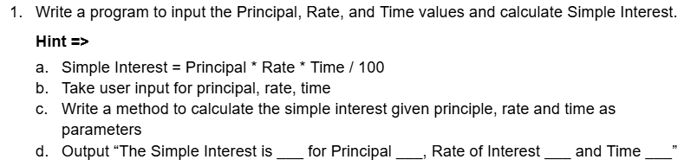

import java.util.Scanner;

public class SimpleIntrest{

public static double IntrestCalculation(double principle,double rate , double time){

double intrest = (principle\*rate\*time)/100;

return intrest;

}

public static void main(String[] args){

Scanner input = new Scanner(System.in);

System.out.printf("Enter the principle: ");

double principle = input.nextDouble();

System.out.printf("Enter the time: ");

double time = input.nextDouble();

System.out.printf("Enter the rate: ");

double rate = input.nextDouble();

//SimpleIntrest intrest= new SimpleIntrest();

double intrest = SimpleIntrest.IntrestCalculation(principle,rate,time);

System.out.printf("The Simple Intrest is: %.2f",intrest);

}

}   
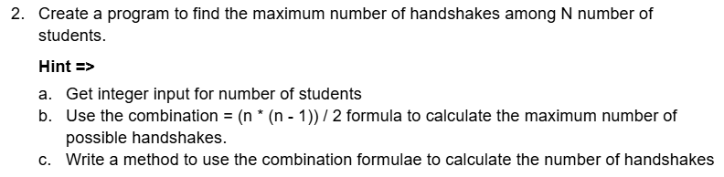

import java.util.Scanner;

public class TotalNumberOfHandshakes{

public static int TotalHandshakes(int number){

int total = (number \* (number - 1)) / 2;

return total;

}

public static void main(String[] args){

Scanner input = new Scanner(System.in);

System.out.printf("Enter the number of people: ");

int number = input.nextInt();

int totalhandshakes = TotalNumberOfHandshakes.TotalHandshakes(number);

System.out.printf("The total number of handshakes are: %d",totalhandshakes);

}

}



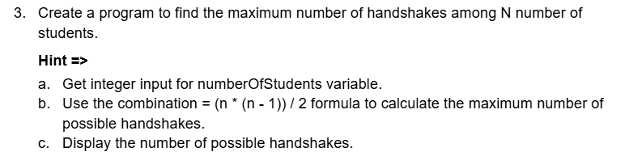

import java.util.Scanner;

public class TotalNumberOfHandshakes{

public static int TotalHandshakes(int number){

int total = (number \* (number - 1)) / 2;

return total;

}

public static void main(String[] args){

Scanner input = new Scanner(System.in);

System.out.printf("Enter the number of people: ");

int number = input.nextInt();

int totalhandshakes = TotalNumberOfHandshakes.TotalHandshakes(number);

System.out.printf("The total number of handshakes are: %d",totalhandshakes);

}

}



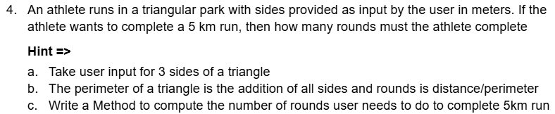

import java.util.Scanner;

public class TotalRounds{

public static double Rounds(double side1,double side2,double side3){

double perimeter = (side1+side2+side3)\*0.001;

double totalrounds = 5/perimeter;

return totalrounds;

}

public static void main(String[] args){

Scanner input = new Scanner(System.in);

System.out.printf("Enter 1st side(in meters): ");

double side1 = input.nextDouble();

System.out.printf("Enter 2nd side(in meters): ");

double side2 = input.nextDouble();

System.out.printf("Enter 3rd side(in meters): ");

double side3 = input.nextDouble();

double totalround = TotalRounds.Rounds(side1,side2,side3);

System.out.printf("The total number of rounds you must run are: %.2f",totalround);

}

}



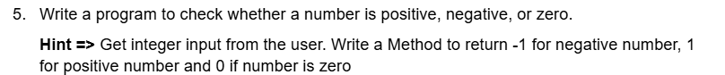

import java.util.Scanner;

public class NumberAnalysis{

public static int Analysis(int number){

if (number>0){

return 1;

}

else if (number ==0){

return 0;

}

else{

return -1;

}

}

public static void main(String[] args){

Scanner input = new Scanner(System.in);

System.out.printf("Enter the number: ");

int number = input.nextInt();

int ans = NumberAnalysis.Analysis(number);

System.out.printf("%d",ans);

}

}



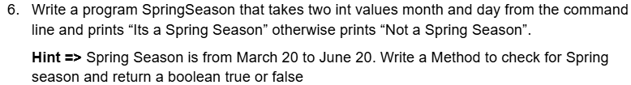

import java.util.Scanner;

public class IsSpringSeason{

public static boolean IsSpring(int day, int month){

if(month==4 || month==5 ){

return true;

}

else if(month==3 && day>=20){

return true;

}

else if (month==6 && day<=20){

return true;

}

else{

return false;

}

}

public static void main(String [] args){

Scanner input = new Scanner(System.in);

System.out.printf("Enter the day: ");

int day = input.nextInt();

System.out.printf("Enter the month(1-12): ");

int month = input.nextInt();

boolean temp = IsSpringSeason.IsSpring(day,month);

if (temp==true){

System.out.printf("Spring Season");

}

else{

System.out.printf("Not Spring Season");

}

}

}

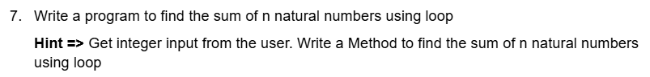

import java.util.Scanner;

public class SumOfNaturalNumbers{

public static int Sum(int number){

int sum=0;

for(int i=1;i<=number;i++){

sum = sum+i;

}

return sum;

}

public static void main(String [] args){

Scanner input = new Scanner(System.in);

System.out.printf("Enter a number: ");

int number= input.nextInt();

int sum = SumOfNaturalNumbers.Sum(number);

System.out.printf("The sum of %d natural numbers is: %d",number,sum);

}

}



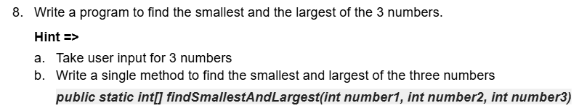

import java.util.Scanner;

public class LargestAndSmallest{

public static int[] findSmallestAndLargest(int number1, int number2, int number3){

int[] finalarr = {number1,number2,number3};

int largest=finalarr[0],smallest=finalarr[0];

for (int i=0;i<3;i++){

if(finalarr[i]>largest){

largest =finalarr[i];

}

}

for (int i=0;i<3;i++){

if(finalarr[i]<smallest){

smallest=finalarr[i];

}

}

int[] arr1={largest, smallest};

return arr1;

}

public static void main(String[] args){

Scanner input = new Scanner(System.in);

System.out.printf("Enter 1st number: ");

int number1= input.nextInt();

System.out.printf("Enter 2nd number: ");

int number2= input.nextInt();

System.out.printf("Enter 3rd number: ");

int number3= input.nextInt();

int[] finalarray = LargestAndSmallest.findSmallestAndLargest(number1,number2,number3);

System.out.printf("The largest of given 3 numbers is %d\n",finalarray[0]);

System.out.printf("The smallest of given 3 numbers is %d\n",finalarray[1]);

input.close();

}

}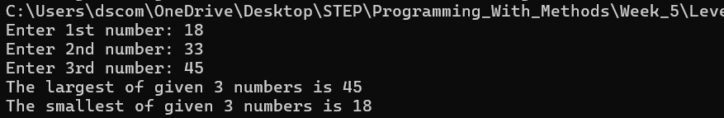

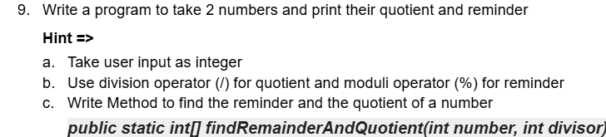

import java.util.Scanner;

public class DivisionProgram{

public static int[] findRemainderAndQuotient(int number, int divisor){

int quotient = number/divisor;

int remainder = number%divisor;

int[] arr = {quotient,remainder};

return arr;

}

public static void main(String[] args){

Scanner input = new Scanner(System.in);

System.out.printf("Enter 1st number: ");

int number1= input.nextInt();

System.out.printf("Enter 2nd number: ");

int number2= input.nextInt();

int[] finalarray = DivisionProgram.findRemainderAndQuotient(number1,number2);

System.out.printf("The quotient is: %d\n",finalarray[0]);

System.out.printf("The remainder is: %d",finalarray[1]);

}

}

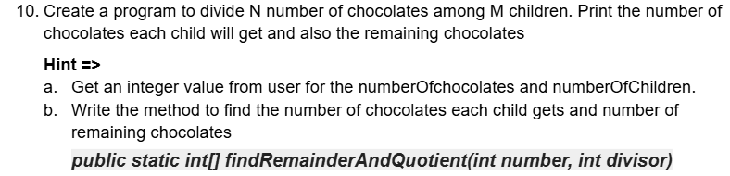

import java.util.Scanner;

public class ChocolateDistribution{

public static int[] findDistributedAndRemainingChocolates(int numberofchildren, int numberofchocolates){

int distributedchocolates = numberofchocolates/numberofchildren;

int remainingchocolates = numberofchocolates%numberofchildren;

int[] arr = {distributedchocolates,remainingchocolates};

return arr;

}

public static void main(String[] args){

Scanner input = new Scanner(System.in);

System.out.printf("Enter number of chocolates: ");

int numberofchocolates= input.nextInt();

System.out.printf("Enter number of children: ");

int numberofchildren= input.nextInt();

int[] finalarray = ChocolateDistribution.findDistributedAndRemainingChocolates(numberofchildren,numberofchocolates);

System.out.printf("The number of chocolates each child gets is: %d\n",finalarray[0]);

System.out.printf("The left over chocolates are: %d",finalarray[1]);

}

}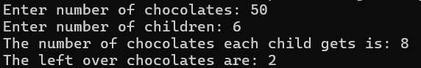

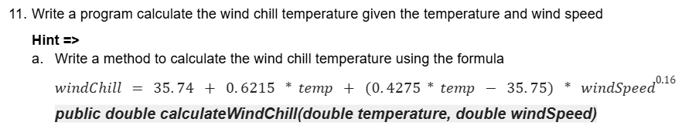

import java.util.Scanner;

public class WindChillCalculator{

public static double calculateWindChill(double temprature, double windSpeed){

double windChill = 35.74 + 0.6215 \*temprature + (0.4275\*temprature - 35.75) \* windSpeed\*0.16;

return windChill;

}

public static void main(String[] args){

Scanner input = new Scanner(System.in);

System.out.printf("Enter temprature: ");

double temp = input.nextDouble();

System.out.printf("Enter windspeed: ");

double windspeed = input.nextDouble();

double windchill = WindChillCalculator.calculateWindChill(temp,windspeed);

System.out.printf("The windchill is : %.2f",windchill);

}

}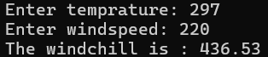

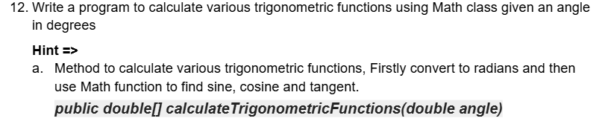

import java.util.Scanner;

public class TrigonometryFunctions{

public static double[] calculateTrigonometricFunctions(double angle){

double sinofangle=Math.sin(angle);

double cosofangle=Math.cos(angle);

double tanofangle=Math.tan(angle);

double[] arr ={sinofangle,cosofangle,tanofangle};

return arr;

}

public static void main(String[] args){

Scanner input = new Scanner(System.in);

System.out.printf("Enter angle in degrees: ");

double angleindegrees = input.nextDouble();

double angleinradian = (angleindegrees\*3.14)/180;

double[] finalarr = TrigonometryFunctions.calculateTrigonometricFunctions(angleinradian);

System.out.printf("The sine of the angle given is: %.4f\n",finalarr[0]);

System.out.printf("The cosine of the angle given is: %.4f\n",finalarr[1]);

System.out.printf("The tan of the angle given is: %.4f",finalarr[2]);

}

}

